In this task, I created a basic E-commerce database using PostgreSQL through the Ubuntu terminal with the psql command-line tool. I designed and created tables such as users, product, cart, and cart_item ETC using SQL queries.
The database includes proper primary keys, foreign keys, constraints, and timestamps to maintain data integrity and relationships between tables.
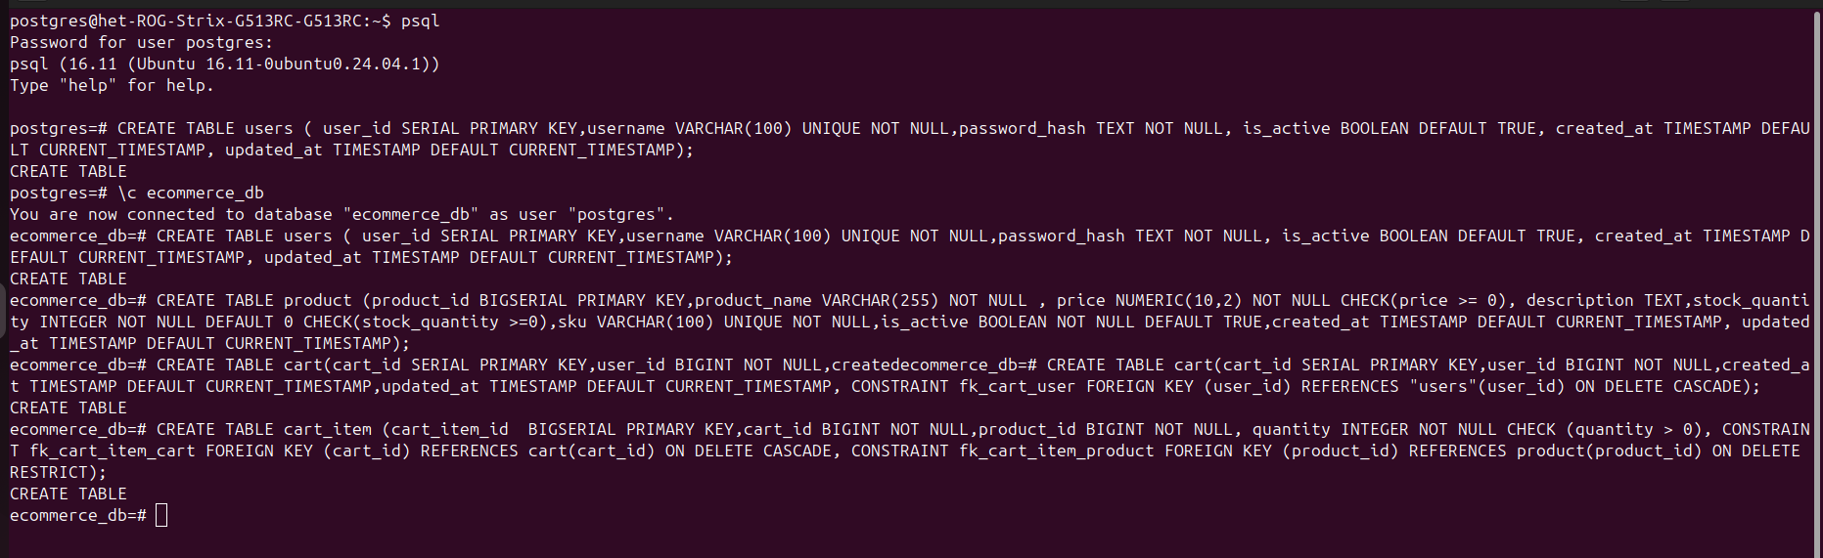

All Table List

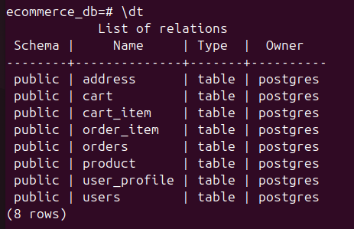

In this step, I inserted a sample record into the users table using an INSERT INTO SQL command in PostgreSQL. The data includes user details such as username, email, password_hash, account status, and timestamps.

In this step, I updated the price of a product in the product table using an UPDATE SQL command. The product price was changed based on the product_id, and the updated_at timestamp was also updated to the current time.

